NAME : SHAKUNTALA DEVI AGE : 85 YRS/ F
Refd. By DR.: A K SINGH MCH(NEURO) DATE: Thursday, February 19, 2026
==============================================================================
This Scan has been Proudly done on Brand New, Most Advanced 3 Tesla MRI

M.R.I. STUDY OF BRAIN
Technique: MRI brain performed with standard sequences including T1, T2, FLAIR, DWI/ADC, and SWI.

Findings:
- Parenchyma:
  - Large area of diffusion restriction (DWI hyperintensity / ADC hypointensity) noted in the left MCA territory, consistent with acute infarct.
  - Corresponding T1 hypointensity and mild T2/FLAIR hyperintensity signal changes seen in the same region.
  - Effacement of left-sided cortical sulci and gyri .
- White Matter Changes:
  - Periventricular and deep white matter hyperintensities consistent with Fazekas grade 2 small vessel ischemic changes.
- Mass Effect:
  - Midline shift of approximately 2 mm towards the right.
  - Compression on the right lateral ventricle with mild prominence noted.
- Ventricular System:
  - Mild prominence of the right lateral ventricle secondary to compression of left side.
  - Other ventricles appear within normal limits.
- Hemorrhage/Extra-axial Collections:
  - No SWI blooming. No extra-axial collection.
- Other Structures:
  - Basal ganglia, thalami, brainstem, and cerebellum appear unremarkable.

Impression:
- Large acute infarct in the left MCA territory with diffusion restriction and corresponding signal changes.
- Associated mass effect with 2 mm midline shift to the right, compression of left lateral ventricle, and effacement of left-sided cortical sulci/gyri.
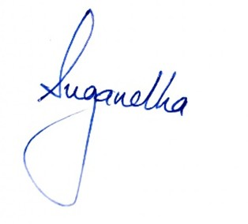
- Fazekas grade 2 chronic small vessel ischemic changes

